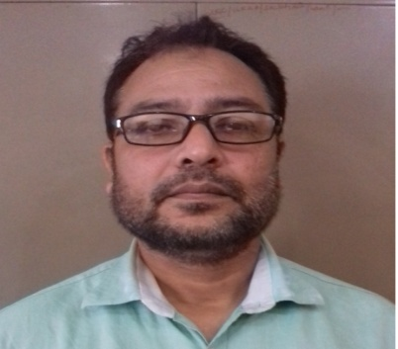

Teacher’s Bio-Data
Name : Md Arshad Alam
Phone: 9614901875
E-Mail : arshad120812@gmail.com
Designation : vice-Principal, Teacher-in-Charge & H.O.D (Arabic)
D.O.B : 10th April 1972
Address :
- Present Address-
South Malda College, P.O. Pubarun, Dist. Malda, Pin Code 732215
- Permanent Address-
Mohalla- Shahmat Hussain Lane, Nera Barihpura Eidgah,Block Jagdishpur, P.O. Head Post office, Dist. Malda, Pin Code 812001.
Adhar Card No. 665075973545
Pan Card No. AEQPA0790K
Seminars
- International Level
1.Suratul Mar’a al- Wadheha Fi riwayate Najib Mahfuz, held on 18th-19th December 2016 at Dept. of Arabic, Gour Banga University.
2.Mother Tongue and Imam Ghazali’s view on Eduation held on 7-8th March 2017 at Dept. of Education, Jadavpur University.
3.The Cultural Impacts of Muslims on Indian Society: A Historical Perspective held on 8-9th March, 2017 at Dept. of History, University of Gour banga.
4. The Issue of Ethics and Morality in the Muallaqa of Zuhair bin Abi Sulma, held on 11-12th December, 2017 at Kaliachak College affiliated to University of Gour Banga.
b) National Level
1. Rabindra Nirtya Natak-e Chanralikaiye partibadi Bhabna, held on 24-25th September, 2014 at south Malda College affiliated to University of Gour Banga.
2. Gambhira; Folkdance and the Means of Social Awareness, held on 2-3rd May, 2015 at Raiganj Surrendranath Mahavidyalaya & Folklore Congress association of India.
3. Musahamato Shah Waliullah fi Al- Nasar al arabi, held on 8th April, 2017 at the Dept. of Arabic, University of Gour Banga.
4. Road-blocks in Higher Education, presented at National Workshop, held on 26-27th February , 2018 at kaliachak college affiliated to University of Gour Banga.
c) State Level
1. Musahamato Abul Hasan Nadwi fil Adab al Arabi al Hindi, held on 17th December, 2015 at the Dept. of Arabic, University of Gour Banga.
Publications
- The Arab Women between Tradition and Modernity- A Phase Of Transition, published from International Research Journal of Interdisciplinary & Multidisciplinary Studies ( IRJIMS) ISSN NO. 2394-7969 & P- ISSN No. 23947950, Vol. -1 , Issue- XI, December, 2015.
- Exploring Feminism: a Case Study of Egypt, journal of Emerging Technology and Innovative research (JETIR), ISSN: 2349-5162 (UGC Approved), Impact Factor-5.87, Vol.5, Issue 11, November-2018.
- Representation of women in Muallaqa, international Journal of Research and Analytical reviews (IJRAR),E- ISSN No.2348-1269, P- ISSN 2349-5138, ( UGC Approved, Impact Factor 5.75), Vol.5, Issue 4, December 2018.
- Exploring Various Dimensions in the Stories of Thousand and One Nights, International Journal of research and Analytical Reviews (IJRAR), E-ISSN 2348-1269, P- ISSN- 2349-5138, ( UGC Approved, Impact Factor 5.75), Vol.5, Issue 4, December 2018.

Signature

